Can you read this map?

1. Objectives

Explain how network devices use routing tables to direct packets to a destination network.

In this activity, given a scenario, you will determine whether high-reliability messaging should be used. You will focus on whether the final message is complete, correct, and delivered in a timely manner.

1. Background/Scenario

**Note:**  It is suggested that students work in pairs; however, if preferred, students can complete this activity individually.

Your instructor will provide you with output generated by a router’s **show ip route** command. Use Packet Tracer to build a topology model using this routing information.

At a minimum, the following should be used in your topology model:

* One Catalyst 2960 switch
* One Cisco Series 1941 Router with one HWIC-4ESW switching port modular card and IOS Version 15.1 or higher
* Three PCs (can be servers, generic PCs, laptops, etc.)

Use the note tool in Packet Tracer to indicate the addresses of the router interfaces and possible addresses for the end devices you chose for your model.

Label all end devices, ports, and addresses ascertained from the **show ip route** output/routing table information in your Packet Tracer file. Save your work in hard or soft copy to share with the class.

1. Required Resources

* Packet Tracer software program.
* Routing **Table 1** - You can use the table to assist one another as you read the information provided, and then construct the model using Packet Tracer.

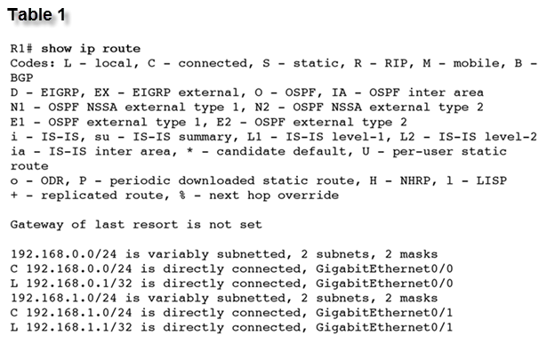

1. Reflection
2. What was the hardest part of designing this network model? Explain your answer.

____________________________________________________________________________________

____________________________________________________________________________________

____________________________________________________________________________________